**Summary Chapter 7**

**What is planning**

* Planning is the fundamental management function, which involves deciding beforehand, what is to be done, when is it to be done, how it is to be done and who is going to do it.
* It is an intellectual process which lays down an organisation’s objectives and develops various courses of action, by which the organisation can achieve those objectives.
* It chalks out exactly, how to attain a specific goal.

**Types Of Plans**

|  |  |  |
| --- | --- | --- |
| **Strategic ( Long Term)** | **Tactical ( Short Term)** | **Operational ( Internal)** |
| Strategic plans are made to achieve the overall organisational goals. They achieve strategic goals through effective allocation of resources over different functional/ product areas. They match the organisational strengths and weaknesses with the environmental opportunities and threats. They are comprehensive and general in nature. They are made for all functional areas of business. They are made by the top-level managers in consultation with board members and middle- level managers and generally relate to a period of more than 5 years. | Tactical plans are the means to support and implement strategic plans. They are made to achieve tactical goals of the organisation. They are related to departmental goals of the enterprise. These plans are made by middle-level managers in consultation with lower-level managers and normally relate to intermediate period of 1 to 5 years. While strategic plans are general in nature, these plans are more specific and precise. | Operational plans support the tactical plans. They are made to achieve operational goals of the enterprise. These plans are highly specific and determine what different sections of the organisation need to perform. While resources are allocated in strategic plans, their efficient use to achieve overall organisational goals is ensured by operational plans. |

**The Planning Process**

* Analysing the environment
  + (SWOT is used to perform the analysis aspect of the environment)
    - Strength

Internal Factor

* + - Weakness
    - Opportunity

External Factor

* + - Threats
  + Looks at both internal and external environment of the company.
* Setting objectives
* Determining requirements
* Assessing resources
* Developing action plans
* Implementing Plans
* Monitoring outcomes

**Decision Making Concepts**

Decision-making is the **process** of selecting a best alternative course of action; from among a number of alternatives given to management or developed by it after carefully and critically examining each alternative.

**Two Phases of Decision Making**

**Formulation**

* See the problem and try to gather more details and what can be the possible ways to solve it

**Solution**

* Considering alternatives and also choosing the best solution to the problem

**Decision Making Process**

* Identify Decision Situations
* Develop Objectives and Criteria
* Generate Alternatives
* Analyse Alternatives
* Select Alternatives
* Implement Decision
* Monitor and Evaluate Results

**Important key terms**

**Retrospective** is looking back on or dealing with past events or situations.

**Perceptual distortions** are incorrect understanding or abnormal interpretation of a perceptual experience. A perceptual distortion occurs when a persons responses to stimuli varies from how it is commonly perceived

**Heuristic** is any approach to problem solving or self-discovery that employs a practical method that is not guaranteed to be optimal, perfect or rational, but which is nevertheless sufficient for reaching an immediate, short-term goal.

**Explicit** means stated clearly and in detail

**Satisficing** is a decision-making strategy or cognitive heuristic that entails searching through the available alternatives until an acceptability threshold is met.

**Ambiguity** means the quality of being open to more than one interpretation

**Multiple Advocacy** - a process to improve decision making by assigning several group members to represent the opinions of various constituencies that might have an interest in the decision.

**Dialectical inquiry** is a form of qualitative research which utilizes the method of **dialectic**, aiming to discover truth through examining and interrogating competing ideas, perspectives or arguments.

**Devil’s Advocate** means a person who expresses a contentious opinion in order to provoke debate or test the strength of the opposing arguments.

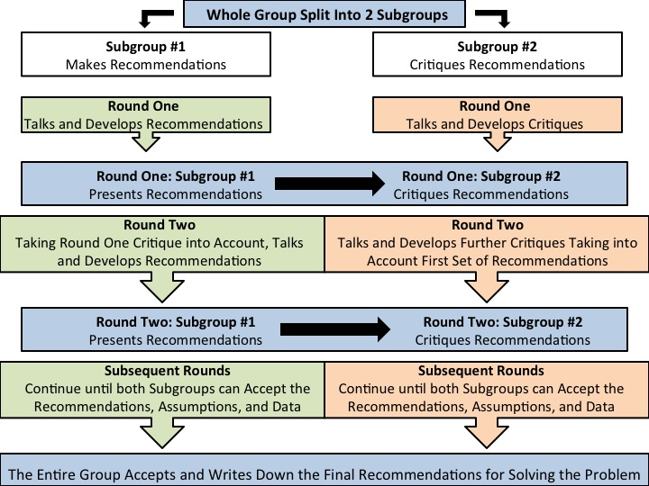

Difference between Devil’s Advocacy and Dialectic Inquiry

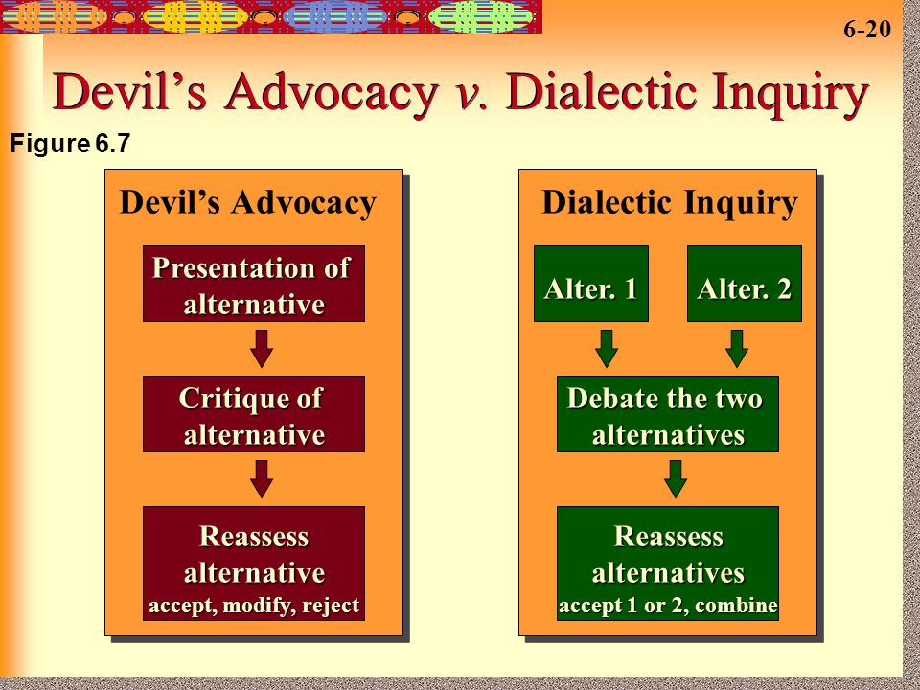

The **Delphi method** is a forecasting process framework based on the results of multiple rounds of questionnaires sent to a panel of experts. Several rounds of questionnaires are sent out to the group of experts, and the anonymous responses are aggregated and shared with the group after each round.

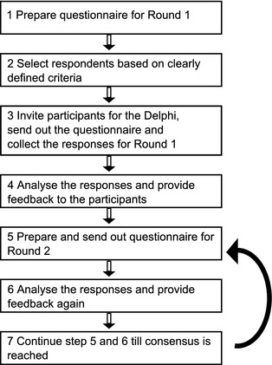

Figure 1: Delphi Approach

**Nominal Group Technique** is described as a technique to improve group decision making that brings people together in a very structured meeting that does not allow much verbal communication. The group decision is a mathematically pooled outcome of individual votes.

**Gresham's Law of Planning** states that a person with responsibility for both routine activities and long-term planning is likely to find the routine activities taking the greater part of his time.

